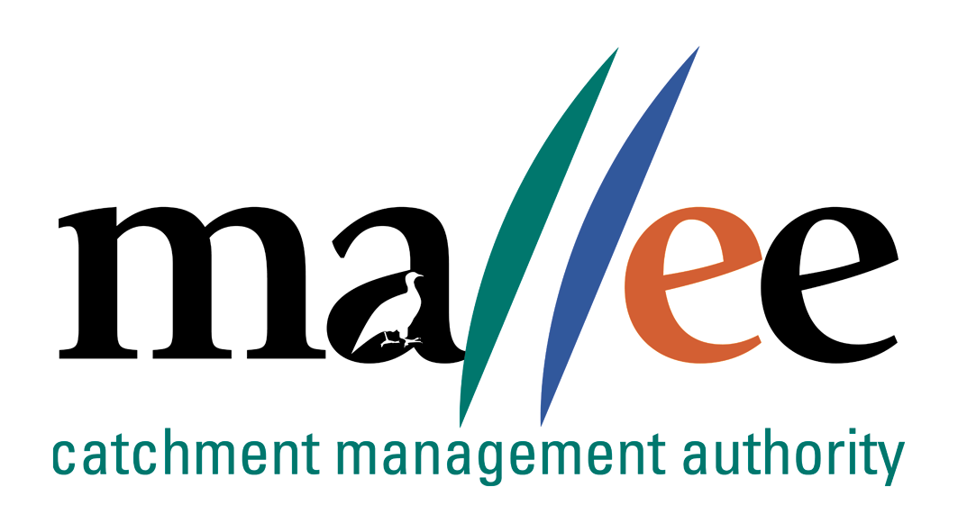 | WORKS ON WATERWAYS PERMIT  Application Form
Document Reference No: FORM 031-388

APPLICATION FOR A PERMIT
TO CONSTRUCT AND OPERATE WORKS ON A WATERWAY
Water Act, 1989: Section 67 and Mallee CMA By-law No.2 Waterways Protection, 2024
THE APPLICANT MUST COMPLETE ALL THE DETAILS ON THIS FORM AND ATTACH SUPPORTING INFORMATION AS REQUIRED

- Applicant Details
Full Name:
Organisation / Company:
Postal Address:
Contact Numbers: | Ph: | Mobile:
Email Address:

- Landowner Details
NB: Where the applicant is not the landowner, written consent from the landowner must be submitted with the application.
Full Name:
Postal Address:
Contact Numbers: | Ph: |  | Mobile:
or if Crown Land
Is site situated on Crown Land  (please tick): |  | o Crown Land  (Written consent must be obtained from the Crown Land Management Unit of the Department of Environment, Land, Water and Planning)

- Contractor Details (the person who will be doing the work – if applicable)
Full Name:
Company
Contact Numbers: | Ph: | Mobile:

- Details of land where works are proposed
Address:
Town:
Site GPS Coordinates (GDA 94 Vic map): |  | Easting: |  | Northing:
CA: or |  |  | Lot No.:
Section: |  |  | PS No.:
Parish:

- Waterway Details
Name of Waterway:
Tributary of:

- Details of Proposed Works
o Access Crossing - Bridge | o Vegetation Removal | o Waterway Deviation
o Access Crossing - Culvert | o Pipeline - Bored | o Jetty
o Access Crossing - Ford | o Pipeline - Trenched | o Stabilisation (erosion control)
o Stream Clearing | o Stormwater Outlet - Bored | o Stormwater Outlet - Trenched
o Other (describe in your words)
THE FOLLOWING INFORMATION MUST BE SUBMITTED WITH THIS APPLICATION
- Proposed Works
(Please provide a written description of the works and the proposed works method e.g. I wish to install a culvert crossing using a single 600mm diameter reinforced concrete pipe with concrete capping.)

- Location Plan (Please provide a sketch or include a map so that the site can be located)

- Sketch of proposed work (Include dimensions, materials, location of waterway, roads etc.)

- Sketch of waterway cross section (Include approximate dimensions)

- What measures will be undertaken to protect the bed and banks of the waterway? (Please describe)

- What sediment control measures will be implemented during the works? (Please describe)

- Cultural Heritage Management Plan
Some ground disturbing activities may require the preparation of a Cultural Heritage Management Plan (CHMP) by a suitably qualified Heritage Advisor. It is your responsibility to determine whether or not a CHMP is required. For further information please contact Aboriginal Victoria at http://www.vic.gov.au/aboriginalvictoria/heritage/planning-and-heritage-management-processes/cultural-heritage-management-plans.html.
Is a Cultural Heritage Management Plan (CHMP) required for the proposed works? | o YES | o NO
If No, a copy of a due diligence report/checklist is submitted with this Works on Waterways Licence application? | o YES | o NO
If Yes, a copy of the CHMP is attached to this Works on Waterways Licence application? | o YES | o NO
PLEASE NOTE: If a Cultural Heritage Management Plan (CHMP) is required, then the CHMP must be approved prior to the issue of other permits and licences. The approved CHMP must be attached to your Works on Waterways Licence application. Licence applications for works requiring a CHMP will not be processed by Mallee CMA until an approved CHMP is received.

- General Provisions

I hereby indemnify Mallee Catchment Management Authority and its officers against all claims, suits or actions arising from injury, loss, damage or death to any persons or property which may arise from the construction, maintenance, existence, or use of the works described in this application.

I consent to an inspection of the site being undertaken by staff of Mallee CMA as part of the assessment of this application for works on a waterway. If a site inspection is required:
I want to be notified in advance | o YES | o NO
I want to attend the inspection | o YES | o NO

- Please include any comments or requirements for access e.g. 4x4 access only, locked gates, stock, etc.

Applicant Name
Applicant Signature |  | Date / /
Landowner Name - if different from the applicant
Landowner Signature: |  | Date: / /

Please forward completed application to:
Mallee Catchment Management Authority
Attention: Floodplain Management
Cnr Eleventh St & Koorlong Ave, Irymple VIC 3498
Post: PO Box 5017, Mildura VIC 3502
Email: Floodplain@malleecma.com.au
Ph: 03 5018 8669

SUPPORTING INFORMATION REQUIRED
Ensure the following information is included with your application.
- Please provide copies of photos if available.
- This application cannot be assessed unless all required information has been provided.
- If there is insufficient space above, please attach additional plans and documents to this application.
- For major works, the Authority may require further information.
For public access bridges:
- Certified engineering design compliant with Australian Standards or Bridge Design Codes
- 100-year ARI flood level. If not available, provide detail of maximum recorded flood level
- Size and number of bridge piers/piles
- Type of fencing or bridge handrails if applicable
- Detail of any variation to the cross-sectional area of the waterway
- If the underside of the bridge deck level is lower than the top of the banks, a hydraulic assessment will be required
For culvert crossings:
- Type, size number of culverts
- Detail of crossing/track location
- Culvert invert level and alignment in relation to the waterway, i.e. on a bend or straight section of the waterway
For stormwater outlets:
- Type, size, outlet height above bed level and alignment in relation to the waterway
- Proposed scour protection
- Water quality controls
- Flow velocities
- Details on how public safety issues are to be addressed
For service crossings:
- Type and method of construction
- For open cut excavation, provide intended depth of pipe below bed level
- For suspended aerial services, provide design detail including height above bed and bank level
For vegetation clearing/management:
- Please contact Mallee CMA for further advice.
For sand and gravel extraction or stream deviation:
- Please contact Mallee CMA for further advice

