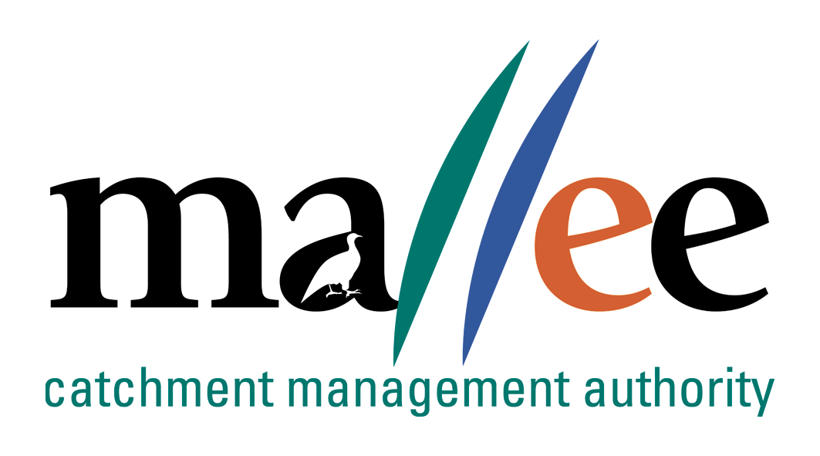 | APPLICATION FOR ACCESS TO PERSONAL INFORMATION
Document Reference No: FORM 046-086
This form can be used to apply for access to personal information that is held by the Mallee Catchment Management Authority (CMA). For further information read the Mallee CMAs Privacy and Data Protection Policy.
Please note: You may be referred to the Freedom of Information access process or other relevant legislation, in which case you will be advised of the appropriate steps to take.
As a general rule you can only apply for access to your own personal information, not anyone else's personal information. Parents of minors, legal guardians and those with legal authority may request access on behalf of their children or wards etc. If you are requesting access on behalf of someone else, you will be required to provide proof of your authority to do so.
The use of this form is optional, however, to assist our privacy staff, it is important that you include all the required information in a legible format. If more space is required, please attach additional pages.

Applicant Details
Applicant Name:
Postal Address:
Town: |  | Postcode
Email:
Phone Number:
Please advise our office as soon as possible if any of your contact details change

Request for Access From
Office / Unit
Detailed Information Request
Have you applied for access to personal information previously? |  | ☐ YES ☐ NO
If YES, please provide outcome of that request

Please sign and date this form and return to Mallee CMA at the address provided below:
Name:
Signature: |  | Date:

Return to Mallee CMA
Chief Finance Officer
Mallee Catchment Management Authority
PO Box 5017
MILDURA VICTORIA 3502
Email: foi@malleecma.com.au
Telephone: (03) 5001 8600
Collection Statement: The Chief Finance Officer will use the information you provide to assess and respond to your request for access to personal information. We will usually disclose your request to the appropriate area where your information is held and, if necessary, to other members of the appropriate area who are required to assist in addressing your request, or where disclosure is required by Law.

File Action: Register in ECM at: Corporate Services/OVIC/Privacy and save to HR Personnel file if relevant

