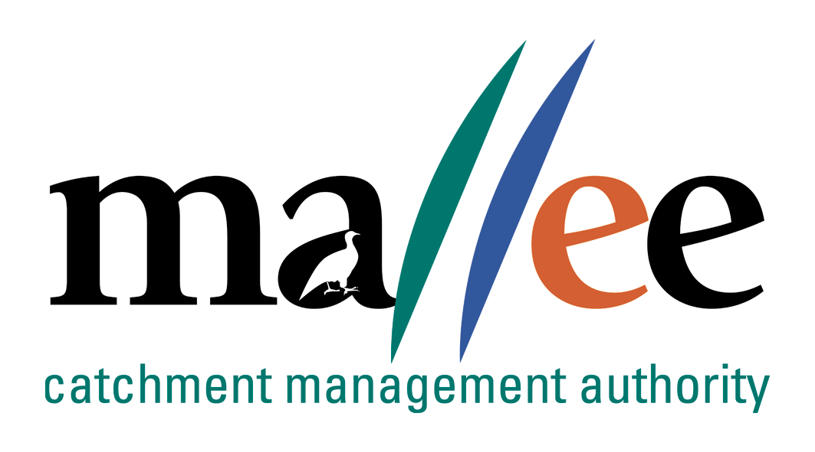 | PRIVACY COMPLAINT FORM
Document Reference No: FORM 046-191
This form is to assist you in making a complaint about the handling of your personal information by the Mallee Catchment Management Authority or a contracted service provider of the Authority under the Privacy and Data Protection Act 2014.
If more space is required, please attach additional pages, although the use of this form is optional and you may choose to provide a complaint in another format, please ensure all information is legible.
Your details
Name
Address
Town |  | Postcode
Phone |  | Email
Please advise our office as soon as possible if any of your contact details change
Your complaint
You may only complain about the mishandling of your own personal information; not about anyone else’s information. Parents of minors, legal guardians and those with a legal authority may complain on behalf of their children or wards etc. If you are complaining on behalf of someone else, please provide proof of your authority to do so.
I am complaining about:
Mallee CMA business unit
Other organisation
Individual(s)
Contact details (if known)
How do you believe your privacy has been breached?

How has this affected you?

Have you taken this complaint to any other organisation? If so, please provide details

Additional information
Please provide copies (not the original) of any documents that may help us to investigate your complaint (for example, any correspondence or records of conversations you have had with Mallee CMA staff or contracted service providers).
Please sign and date this form and return to Mallee CMA at the address below
Signature |  | Date

Return to Mallee CMA
Please return the completed form and any additional documentation by post or email to:
Meagan Crozier, Chief Finance Officer
Mallee Catchment Management Authority
PO Box 5017, Mildura, Victoria 3502
Email: foi@malleecma.com.au

Privacy Collection Notice:
Mallee Catchment Management Authority will use the information you provide to investigate, conciliate and/or remedy your privacy complaint. We may disclose the information you give us to the individuals or business unit named in the complaint and, if necessary, to others who have information relevant to your complaint. Should the complaint be referred to the Commissioner for Privacy and Data Protection, we may need to disclose some information to the Office of the Commissioner and/or the Victorian Civil and Administrative Tribunal. You may gain access to your privacy complaint information by contacting the Privacy Team at the details above.

File Action: ECM/OVIC/Privacy

